**Cost-related performance goals**

The video in this course that covered performance goals focused on how to use return on ad spend (ROAS), but there are many other kinds of cost-related performance goals to consider. This reading describes performance goals for bidding strategies that were introduced earlier in the program. Smart Bidding enables Google Ads to monitor goals to ensure that strategies are optimized to reach those goals. Both Smart Bidding and manual bidding use targets or performance goals for metrics like

* Cost per acquisition (CPA)
* Cost per click (CPC)

***Note:*** *With Smart Bidding, you can use Target CPA and Enhanced CPC strategies. An Enhanced CPC strategy combines manual CPC bidding with Target CPA or Target ROAS.*

**Lower CPA to improve campaign value**

**Note:** Performance goals will vary by campaign. Cost-related information provided below is for illustrative purposes only.

Cost per acquisition (CPA) is the average cost paid for each conversion. If you have comparative data from historical campaigns, you can use the average CPA value as a performance goal. You can then optimize your campaign to try to achieve a lower CPA to improve the value of your campaign.

If you don’t have historical campaign data, you can try using an industry-average value as a starting point. Industry averages are typical values found across an entire industry. CPA for search ads for the auto industry, CPA for Facebook ads for the clothing industry, and CPA for e-commerce are a few examples.

Imagine you’re working for a real estate firm but don’t have historical campaign data. You research and find that the industry-average CPA for real estate search ads is $41.14, so you set your target CPA at $40 (red line in chart below). Your budget for search ads is $10,000 so you’ll be aiming for at least 250 conversions to meet or exceed the target CPA of $40. Any number of conversions below the red line would exceed your target.

**Number of conversions for improvement** = Budget / CPA = $10,000 / $40 = 250

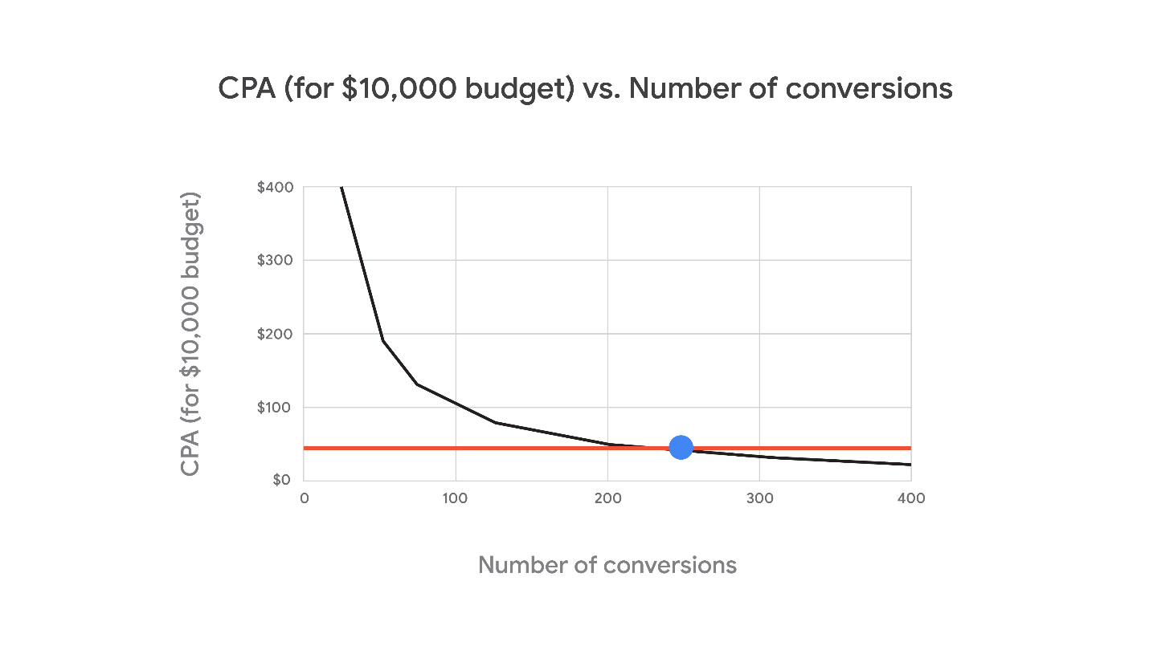Chart shows cost per acquisition versus number of conversions for a $10,000 budget. A minimum goal of 250 conversions is shown as the target based on a CPA of $40

If a conversion is defined as a potential customer requesting information about realty services, you’ll need at least 250 people to take that action after seeing your search ads. If more than 250 people take that action, you will have improved your campaign’s value above the industry average for real estate.

**Use daily spend to manage CPC**

**Note:** Performance goals will vary by campaign. Cost-related information provided below is for illustrative purposes only.

Cost per click (CPC) is a metric used in pay-per-click (PPC) advertising. One way you can control cost is to manage CPC on a per-campaign basis. You can allocate more budget to the PPC campaigns that are the highest priority**.**

Going back to the example of working at a real estate company, if you’re running national search ads for multiple regions, but the northwest sales region has a higher priority than the southwest sales region, you can spend more of your budget on the PPC campaign for the northwest region. Assuming the maximum CPC is $0.50 for both regions, you can allocate a daily spend that’s higher in the northwest to achieve more clicks in that region. If you assume a daily spend of $200 for the northwest region and $100 for the southwest region, the following calculations apply:

**Number of clicks in the northwest region** = Daily Spend / CPC = $200/$0.50 = 400 clicks **Number of clicks in the southwest region** = Daily Spend / CPC = $100/$0.50 = 200 clicks

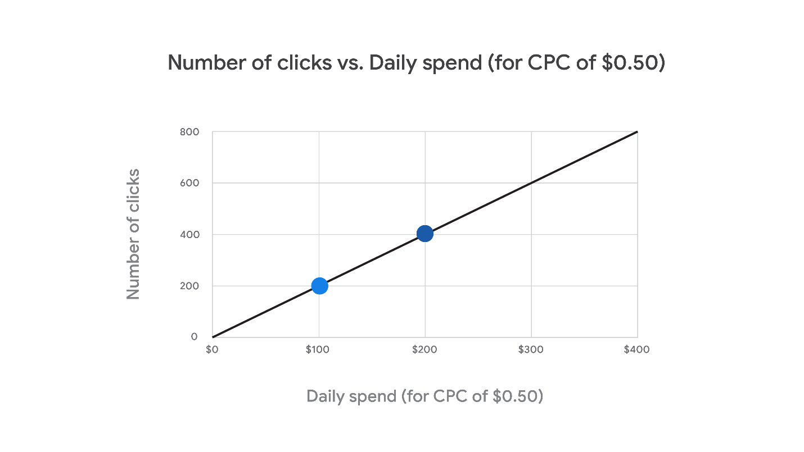Chart shows number of clicks versus daily spend for a CPC of 50 cents. 400 clicks at a daily spend of $200 and 200 clicks at a daily spend of $100 are two data points for comparison.

Based on the difference in the daily spend, the number of clicks you are willing to pay for in the northwest region (darker blue datapoint) is greater than the number of clicks you are willing to pay for in the southwest region (lighter blue datapoint). You can control the daily spend during the campaign to manage performance outcomes in each region.

**Key takeaways**

Understanding CPA, ROAS, and CPC helps you manage campaigns. Daily spend or CPC adjust to maximize the number of conversions. With Smart Bidding, an Enhanced CPC strategy combines manual bidding with a target CPA or target ROAS.